# Lab Exercises: HTML5 and CSS

Problems for exercises and homework for the [“Software Technologies” course @ SoftUni](https://softuni.bg/courses/software-technologies).

# HTML5

## Welcome to HTML

Create a Web page, which looks like the screenshot:

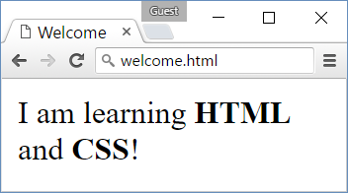

* *File name:* welcome.html
* *Title:* Welcome
* *Paragraph of text:* I am learning **HTML** and **CSS**!

### Hints

* Modify the code from the examples in the slides.

## Headings

Create a Web page like the screenshot:

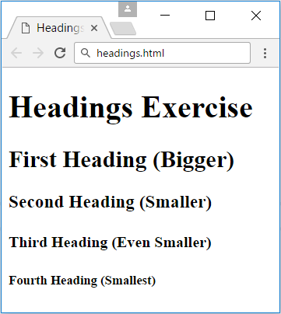

* *File name*: headings.html
* *Title:* Headings
* *Large heading:* “**Headings Exercise**”
* *Smaller headings:* [**First**…**Fourth**] **Heading**

### Hints

* Use <h1> through <h5> tags.

## Paragraphs

Create a Web page like the screenshot:

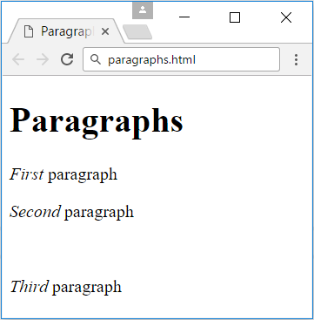

* *File name*: paragraphs.html
* *Title:* Paragraphs
* *Large heading:* “**Paragraphs**”
* *Emphasized text:* **First**, **Second** and **Third paragraph**
* **Empty line** between the **second** and **third** paragraph

### Hints

Use **<p>**, **<em>** and **<br/>** tags.

## My TODO List

Create a Web page like the screenshot:

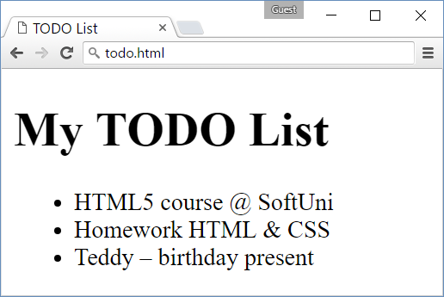

* *File name:* todo.html
* *Title:* TODO List
* *Large heading:* My TODO List
* *Unordered list:* <ul>…</ul>
* *Three list elements:* **<li>…</li>**

### Hints

* Create an HTML file named todo.html like in the previous exercises.
* Assign the <title>…<title>.
* Use <ul>…</ul> to create an unordered list.
* Put each of the list items in a <li>…</li> tag.
* Use **&amp;** for the **ampersand** (**&**)
* Use &ndash; for the **long hyphen** (**–**).

## Hello HTML

Create a Web page like the screenshot:

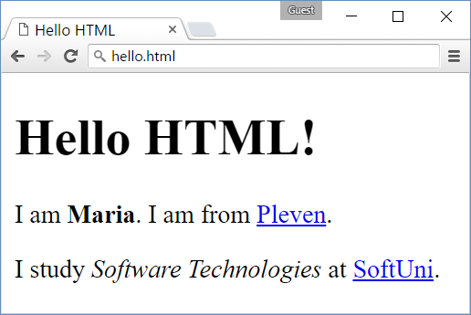

* *File name:* hello.html
* *Title:* “**Hello HTML**”
* *Large heading:* “**Hello HTML!**”
* *Paragraph of text:* I am <**your name** (**bold**)>. I am from <**your town as link to your town's Web site**>.
* *Paragraph of text:* I study **<*specialty* (*italic*)>** at <**link to SoftUni**>.

### Hints

* Modify the code from the example in the slides.

## Website

Create three web pages connected to each other by local links like the screenshot below:

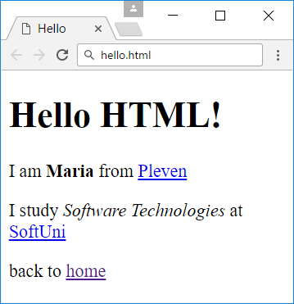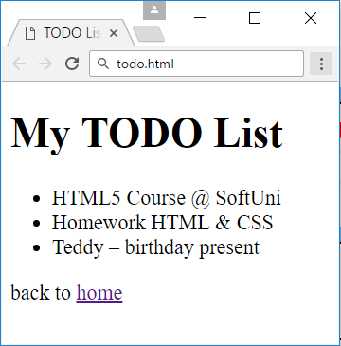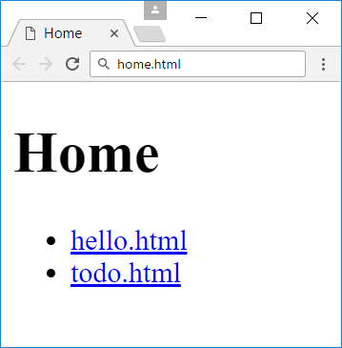

* *File names:* home.html, todo.html, hello.html
* *Titles:* **Home**, **TODO List**, **Hello**
* *Large headings:* **Home**, **My TODO List**, **Hello HTML!**
* *Unordered lists:* home.htmlandtodo.html
* *Hyperlinks:* home.html - **links** to todo.html and hello.html
* *Home hyperlinks:* todo.html and hello.html

### Hints

You can use the todo.html and hello.html pages that you have created for the previous exercises.

* Create home.html and use <ul>…</ul> to create an unordered list with the links
* Use <a href="">…</a> to create a hyperlink inside a <li>…</li> element
* Use href="todo.html" to connect home.html to todo.html and href="hello.html" to connect it with hello.html.
* Create “**back to home**”links following the same logic

## Fruits

Create a Web page like the screenshot:

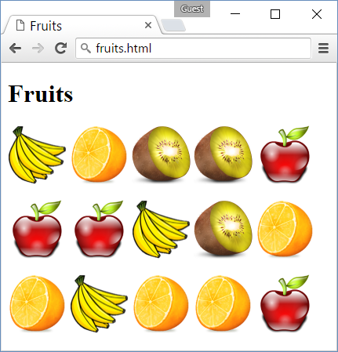

Use the fruit images given in assets:

* images\apple.png
* images\banana.png
* images\kiwi.png
* images\organge.png

### Hints

* Create a HTML page named “**fruits.html**” titled “**Fruits**”.
* Use **3** paragraphs, each holding **5** images.
* Put the images in **each** paragraph (row) in a **sequence**, one after another.

## Forms

Create a Web page like the screenshot:

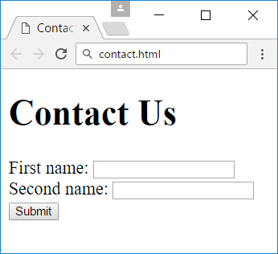

* *File name:* contact.html
* *Title:* “**Contact Us**”
* *Large heading:* “**Contact Us**”
* *Form: holding three elements*
* **Two** text boxes
* *Button:* with text “**Submit**”

### Hints

* For the form use **<form>…</form>**
* Inside the form place two textboxes using **<input type="text" />**
* Use **<input type="submit" value="Submit" />** for the button

# CSS

## Colors

Create a Web page like the screenshot:

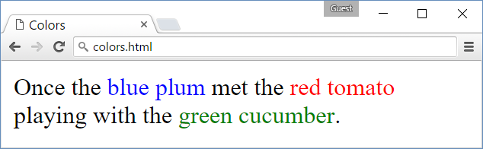

### Hints

* Use a paragraph <p>…</p> to hold the text.
* Use <span style="…">text</span> for the colored text

## Borders

Create a Web page like the screenshot:

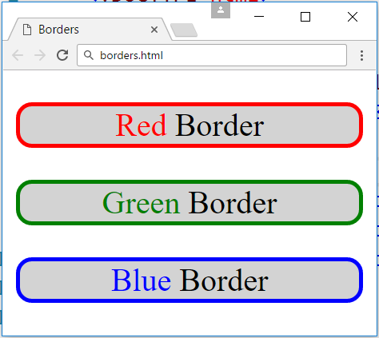

### Hints

* Use three paragraphs <p>…</p> to hold the text
* Use <p style="">…</p> to style the paragraphs
* Use <span style="…">text</span> for the colored text

## Rectangles

Create a Web page like the screenshot:

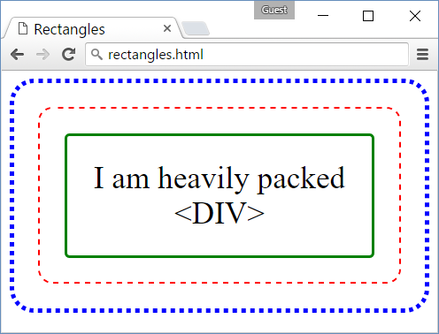

### Hints

* Use 3 nested <div> elements
* **Outside div**: blue dotted border + border-radius + padding
* **Middle div**: red dashed border + border-radius + padding
* **Inner div**: green solid border + border-radius + padding + text-align + font-size
* Use &lt; and &gt; to escape the < and > characters in the text…

## Languages

Create a Web page like the screenshot:

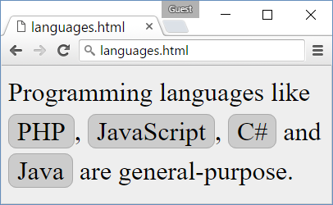

### Hints

* Create HTML file langs.html.
  + Put the text in paragraphs and <span>…</span> tags.
* Create CSS file langs.css.
* Link the CSS file in the HTML header:
  + <link rel="…" href="langs.css">
* In the “**body**” CSS selector in the CSS class define:
  + background:#EEE; line-height:1.5em; font-size:24pt;
* Define and use a CSS class “.lang” for styling the languages:
  + Specify border:1px #AAA, border-radius, background:#CCC, padding

## Contact Us Form

Create a Web page like the screenshot:

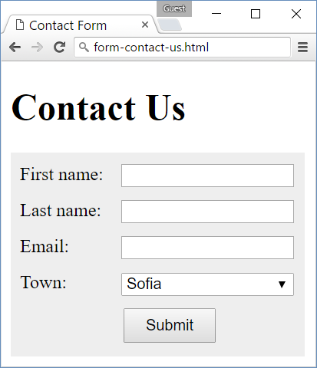

### Hints

1. Create an HTML file contact-us-form.html, put appropriate **title**, put “**Contact Us**” **heading**.
2. Create the **HTML code** to display the form and its fields:  
   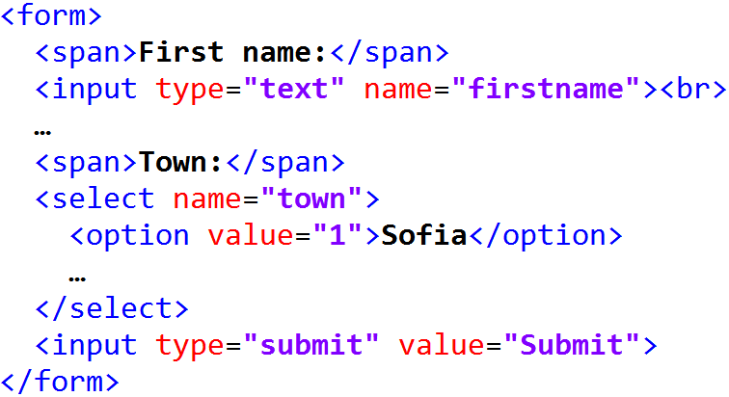
3. In the **CSS file** put some styling to make the for look like at the above screenshot. First define the form background styling:  
   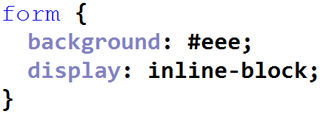
4. Style the **labels** before each form field. They stay in a <span>…</span> tags. Use styling like this:  
   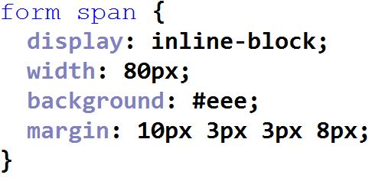

1. Now style the <input>…</input> and <select>…</select> fields:  
   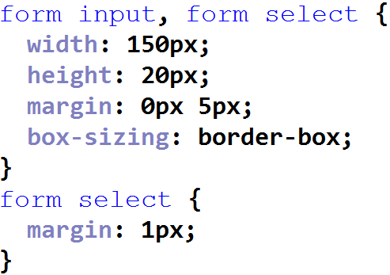
2. Finally, style the “**Submit**” button:  
   